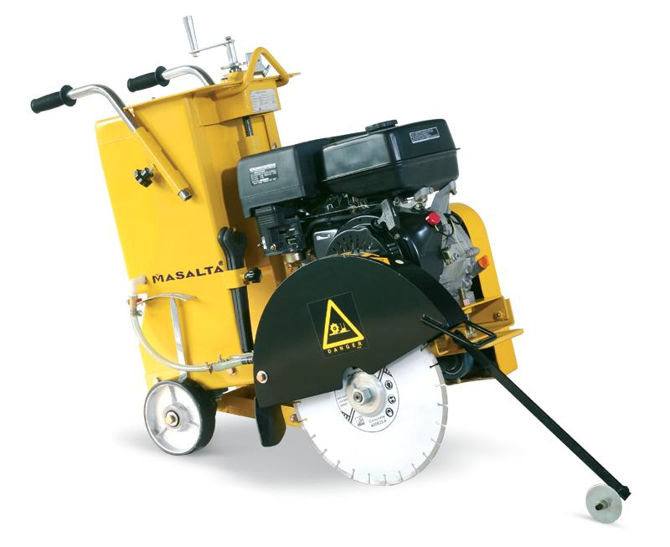
PARTS MANUAL FLOOR SAW MF16
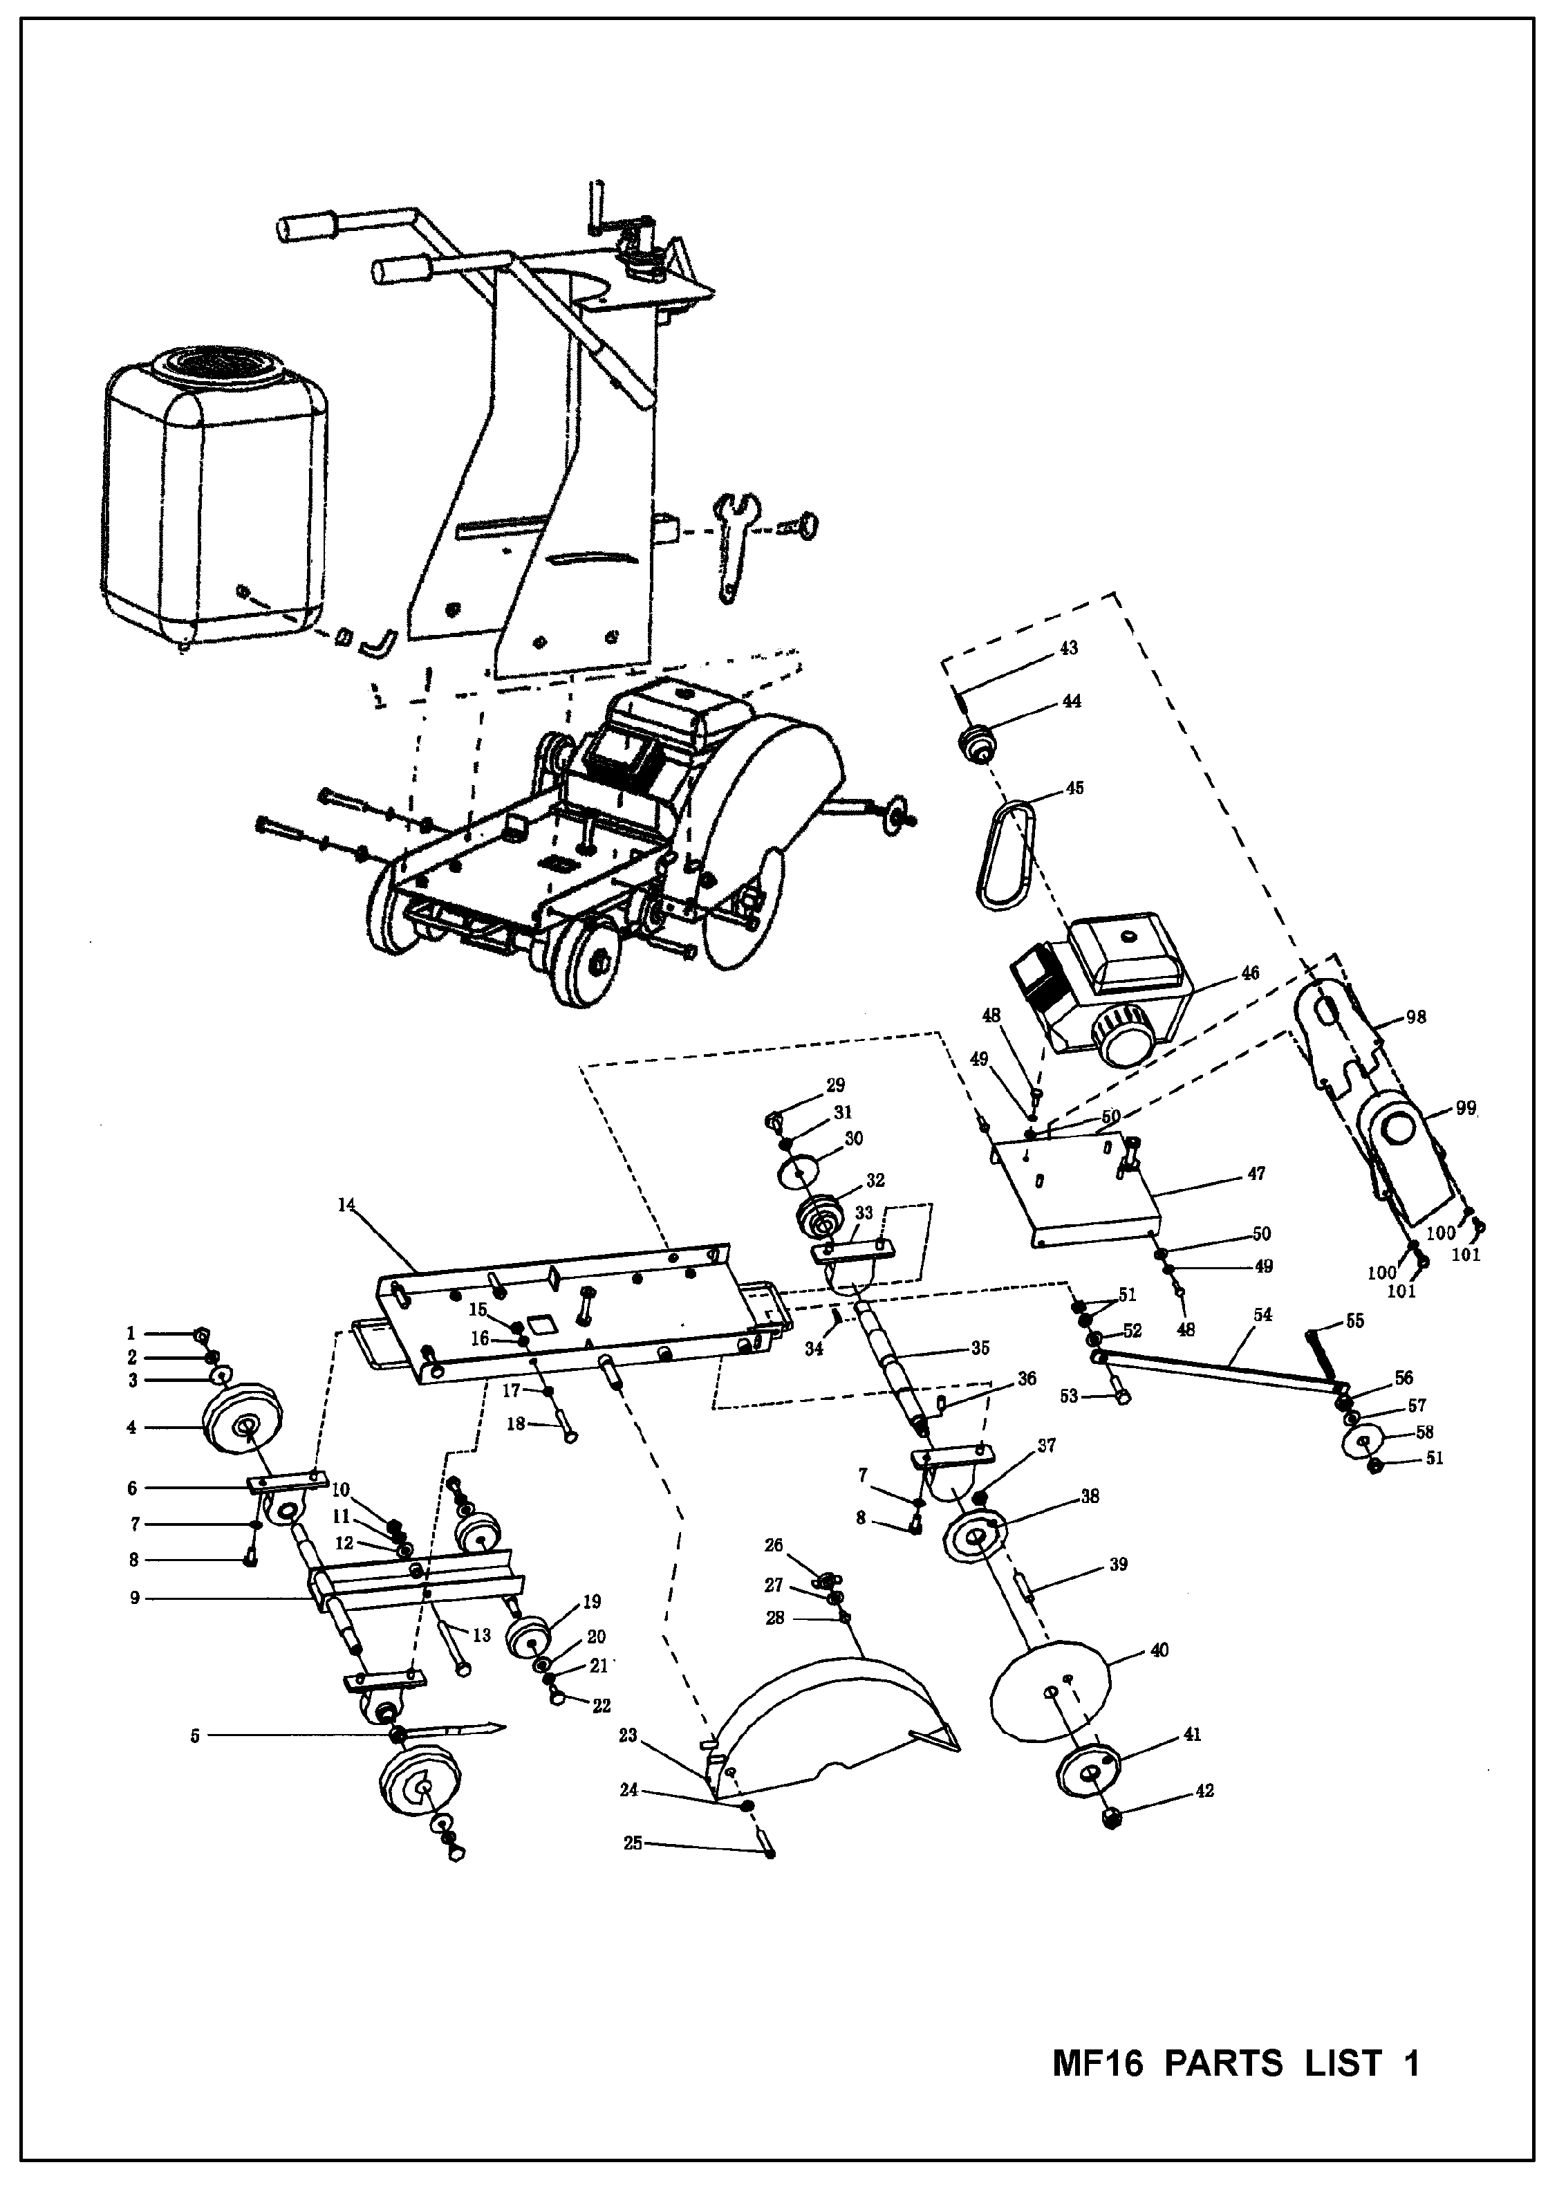
MF16 PARTS LIST 1

ITEM NO. | PART NO. | DESCRIPTION | QTY | ITEM NO. | PART NO. | DESCRIPTION | QTY
1 | 05780012 | BOLT M12X20-GB5780 | 2 | 35 | 18090002 | PRINCIPAL AXIS | 1
2 | 09300012 | SPRING WASHER 12-GB93 | 2 | 36 | 01190006 | PIN C6 - GB119 | 1
3 | 18030104 | DEEP WASHER | 2 | 37 | 06170008 | NUT M8 - GB6170 | 1
4 | 00180303 | RUBBER WHEEL ( REAR) | 2 | 38 | 18090301 | BLADE FLANG (INNER) | 1
5 | 18030103 | INDICATOR | 1 | 39 | 07300008 | PIN | 1
6 | 00180302 | BEARING & BRACKET | 2 | 40 | 00180007 | BLADE | 1
7 | 09300012 | SPRING WASHER 12-GB93 | 8 | 41 | 18090302 | BLADE FLANG (OUT) | 1
8 | 05780012 | BOLT M12-GB5780 | 8 | 42 | 18090004 | NUT | 1
9 | 18030101 | WHEEL RACK MODULE | 1 | 43 | 01096000 | KEY - GB1096 | 1
10 | 06187012 | NUT 12-GB848 | 1 | 44 | 18110001-1 | EINGINE PULLEY FOR DIESEL | 1
11 | 09300012 | SPRING WASHER 12-GB93 | 1 |  | 18110001-2 | ENGINE PULLEY FOR HONDA | 1
12 | 08480012 | WASHER 12-GB93 | 1 |  | 18110001-3 | ENGINE PULLEY FOR ROBIN | 1
13 | 05784012 | BOLT M12 X 120 - GB5784 | 1 | 45 | 01154400-1 | V-BELT SPA-GB11544 FOR DIESEL | 1
14 | 18100000 | BASE ASSY | 1 |  | 01154400-2 | V-BELT SPA-GB11544 FOR PETROL | 1
15 | 06170012 | NUT M12 - GB6170 | 4 | 46 | 00181100-1 | DIESEL ENGINE | 1
16 | 09300012 | SPRING WASHER 12-GB93 | 4 |  | 00181100-2 | HONDA ENGINE | 1
17 | 09700012 | WASHER 12-GB97 | 4 |  | 00181100-3 | ROBIN ENGINE | 1
18 | 05783012 | BOLT M12 - GB5783 | 4 | 47 | 18070000 | BASE ASSY. OF ENGINE | 1
19 | 00180301 | RUBBER WHEEL ( FRONT) | 2 | 48 | 05784010 | BOLT M10 X 30 - GB5784 | 8
20 | 18030102 | DEEP WASHER | 2 | 49 | 09300010 | SPRING WASHER 10 - GB93 | 8
21 | 09300008 | SPRING WASHER 8 - GB93 | 2 | 50 | 09700010 | WASHER 10 - GB97 | 8
22 | 05780008 | BOLT M8 X 20 - GB5780 | 2 | 51 | 06178012 | NUT M12 - GB6178 | 3
23 | 18080000 | BLADE GUARD | 1 | 52 | 08480012 | WASHER 12 - GB848 | 1
24 | 09600010 | WASHER 10 - GB96 | 1 | 53 | 05780012 | BOLT M12 X 45 - GB5780 | 1
25 | 05781010 | BOLT M10 - GB5781 | 1 | 54 | 18010001 | POINTER | 1
26 | 06200010 | NUT M10 - GB62 | 1 | 55 | 05780012 | BOLT M12 X 110 - GB5780 | 1
27 | 09600010 | WASHER 10 - GB96 | 1 | 56 | 18010002 | NUT | 1
28 | 00180008 | SCREW | 1 | 57 | 08480012 | WASHER 12 - GB848 | 1
29 | 05780010 | BOLT M10 X 25 - GB5780 | 1 | 58 | 18010003 | POINTER WHEEL | 1
30 | 18090001 | WASHER | 1 | 98 | 18110002 | INNER BELT GUARD | 1
31 | 09300010 | SPRING WASHER 10 - GB93 | 1 | 99 | 18110003 | OUTER BELT GUARD | 1
32 | 18090005 | PULLEY | 1 | 100 | 18110004 | BOLT M10X35-GB5780 | 2
33 | 00180902 | BEARING & BRACKET | 2 | 101 | 18110005 | WASHER 10 | 2
34 | 01096008 | KEY C8 X 38 - GB1096 | 1 | –– | –––– | –––––––––––– | ––

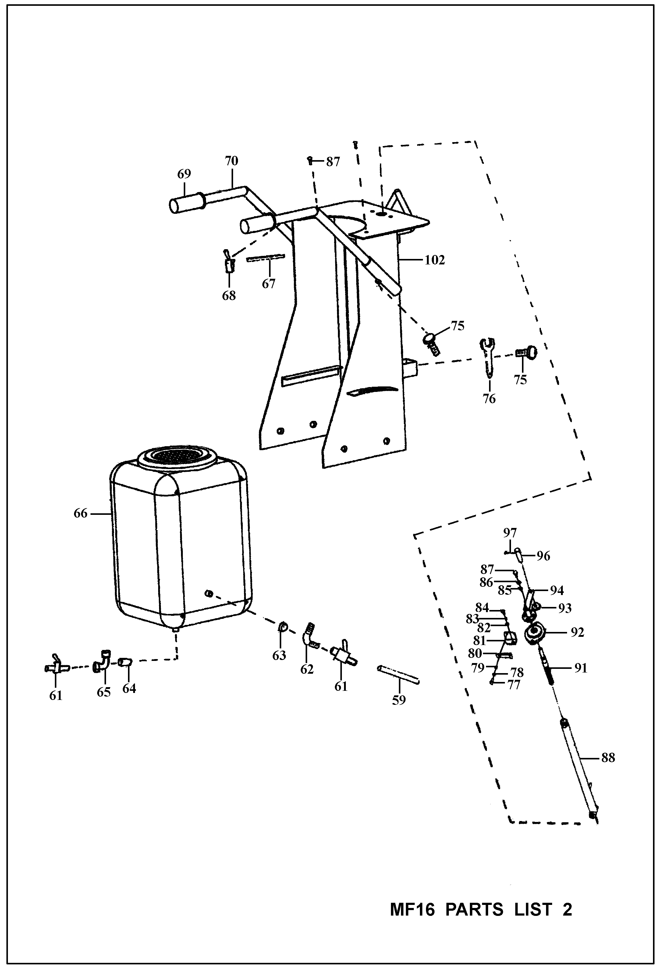

MF16 PARTS LIST 2

ITEM NO. | PART NO. | DESCRIPTION | QTY
59 | 00180006 | PLASTIC PIPE | 3
61 | 00180002 | COCK | 2
62 | 18050006 | ELBOW BEND | 1
63 | 00180501 | NUT | 1
64 | 00180502 | NUT | 1
65 | 18050011 | ELBOW | 1
66 | 18050000-1 | WATER TANK | 1
67 | 00180009 | THROTTLE CABLE | 1
68 | 00180010 | THROTTLE CONTROL | 1
69 | 00180011 | HANDLE BAR GRIP | 2
70 | 18060000-1 | HANDLE LEVER | 2
75 | 00180004 | KNOB | 3
76 | 00180001 | WRENCH | 1
77 | 05781008 | BOLT M8 X 30 - GB5781 | 1
78 | 09300008 | SPRING WASHER 8 - GB93 | 1
79 | 09700008 | WASHER 8 - GB97 | 1
80 | 18030006 | BOARD PLUG | 1
81 | 18030007 | ORIENTATION BOARD | 1
82 | 09700010 | WASHER 10 - GB97 | 2
83 | 09300010 | SPRING WASHER 8 - GB93 | 2
84 | 05781010 | BOLT M10 - GB5781 | 2
85 | 08480008 | WASHER 8 - GB848 | 1
86 | 09300008 | SPRING WASHER 8 - GB93 | 1
87 | 05784008 | BOLT M8 X 20 - GB5784 | 1
88 | 18030200 | MANUAL RAISE/LOWER ASSY. | 1
91 | 18030005 | SCREW | 1
92 | 00180301 | BEARING & BRACKET | 1
93 | 06187010 | NUT M10 - GB6787 | 1
94 | 18030400 | BRACKET | 1
96 | 18030404 | HANDLE GRIP | 1
97 | 07300006 | BOLT M6 - GB73 | 1
102 | 18050012 | WATER TANK HOLDER ASSY | 1

Distributed By

MASALTA ENGINEERING CO., LTD

Add: Weisi Road, Baohe Industrial Estate, Hefei, China Tel: 86-551-4846600, 4846601 Fax: 86-551-4846616 E-mail: sales@masalta.com.cn, masalta@mail.hf.ah.cn, Http://www.masalta.com.cn

Version: 01/08/04

