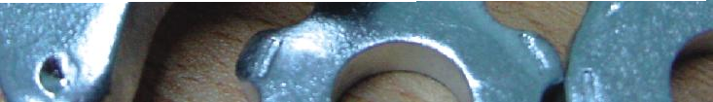

PARTS MANUAL
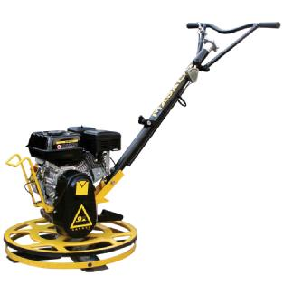
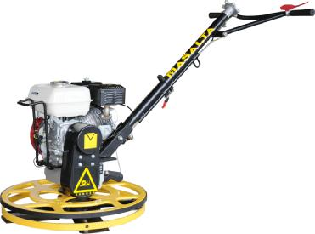
EDGING POWER TROWEL MT24 / MT30
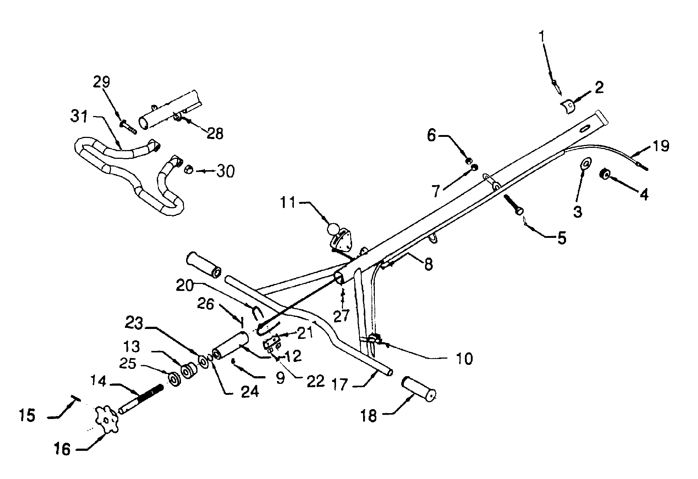
MT24 / MT30 PARTS LIST 1

MT24 / MT30 PARTS LIST 1

ITEM NO. | PART NO. | DESCRIPTION | QTY
1 | M300100001 | SCREW | 2
2 | M300100002 | PLATE | 1
3 | M300100003 | WASHER | 1
4 | M300100004 | SCREW NUT | 1
5 | M300100005 | SCREW | 1
6 | M300100006 | NUT | 2
7 | M300100007 | WASHER | 1
8 | M300100008 | SCREW | 2
9 | M300100009 | SCREW | 1
10 | M300100010 | THROTTLE CONTROL | 1
11 | M300100011 | SAFETY STOP SWITCH ASSY. | 1
12 | M300100012 | SHAFT, TROWEL CONTROL | 1
13 | M300100013 | COLLAR | 1
14 | M300100014 | BOLT | 1
15 | M300100015 | PIN | 1
16 | M300100016 | WHEEL, HAND HANDLE | 1
17 | M300100017 | HANDLE | 1
18 | M300100018 | GRIP | 2
19 | M300100019 | WIRE | 1
20 | M300100020 | TIE WIRE | 1
21 | M300100021 | CLIP | 1
22 | M300100022 | NUT | 2
23 | M300100023 | SPACER | 1
24 | M300100024 | SPRING WASHER | 1
25 | M300100025 | BERING | 1
26 | M300100026 | PIN | 1
27 | M300100027 | SCREW | 1
28 | M300100028 | BRACKET, HANDLE ADJUSTABLE | 1
29 | M300100029 | SCREW | 1
30 | M300100030 | NUT | 1
31 | M300100031 | HANDLE ADJUSTABLE | 1

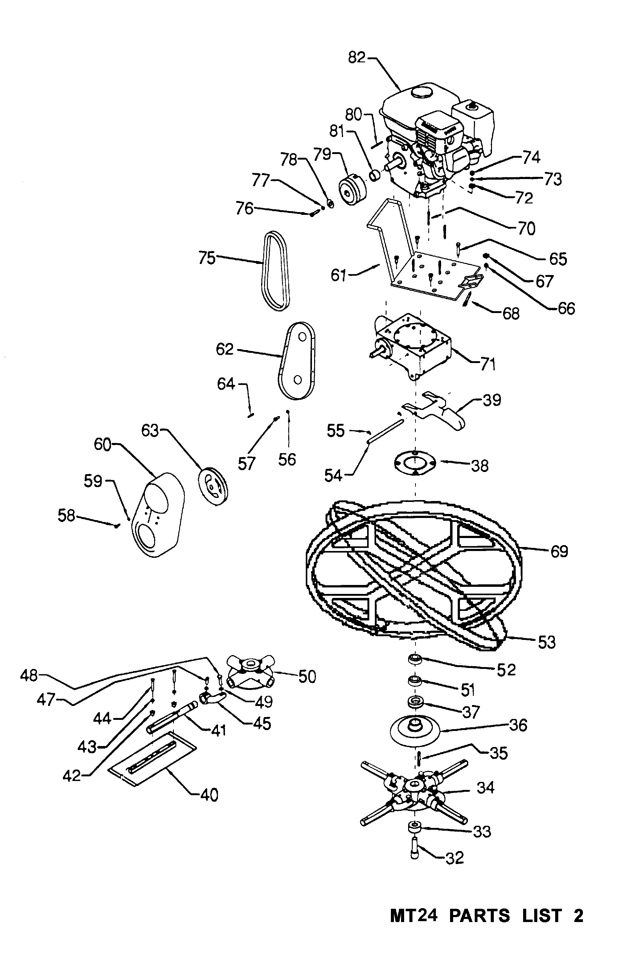
MT24 / MT30 PARTS LIST 2
MT24 / MT30 PARTS LIST 2

ITEM NO. PART NO. DESCRIPTION QTY
32 | M300200001 | SCREW MIZ | 1
33 | M300200002 | THRUST COLLAR | 1
34 | M300300000-1 | SPIDER PLATE ASSY. FOR MT30 | 1
 | M300300000-2 | SPIDER PLATE ASSY. FOR MT24 | 1
35 | M300200003 | PIN | 1
36 | M300200004 | WEAR PLATE FOR MT30 | 1
 | M300200004-1 | WEAR PLATE FOR MT24 | 1
37 | M300200005 | BEARING | 1
38 | M300200006 | WEAR RING | 1
39 | M300200007 | ARM, YOKE | 1
40 | MTBF06105 | BLADE FOR MT30 | 4
 | MTBC04009 | BLADE FOR MT24 | 4
41 | M300300001 | TROWEL ARM EXTENDED FOR MT30 | 4
 | M300300001-1 | TROWEL ARM EXTENDED FOR MT24 | 4
42 | M300300002 | SPACER FOR MT30 | 8
 | M300300002-1 | SPACER FOR MT24 | 8
43 | M300300003 | SPRING WASHER FOR MT30 | 8
 | M300300003-1 | SPRING WASHER FOR MT24 | 8
44 | M300300004 | SCREW FOR MT30 | 8
 | M300300004-1 | SCREW FOR MT24 | 8
45 | M300300005 | TROWEL ARM LEVER FOR MT30 | 4
 | M300300005-1 | TROWEL ARM LEVER FOR MT24 | 4
47 | M300300007 | ROLL PIN FOR MT30 | 4
 | M300300007-1 | ROLL PIN FOR MT24 | 4
48 | M300300008 | RADIUS HEAD SCREW FOR MT30 | 4
 | M300300008-1 | RADIUS HEAD SCREW FOR MT24 | 4
49 | M300300009 | NUT FOR MT30 | 8
 | M300300009-1 | NUT FOR MT24 | 8
50 | M300300010 | SPIDER PLATE ONLY FOR MT30 | 1
 | M300300010-1 | SPIDER PLATE ONLY FOR MT24 | 1
51 | M300200008 | BEARING | 4
52 | M300200009 | BEARING | 4

(TO BE CONTINUED)
MT24 / MT30 PARTS LIST 2

ITEM NO. PART NO. DESCRIPTION QTY
53 | M300400001 | RUBBER RING FOR MT30 | 4
 | M300400001-1 | RUBBER RING FOR MT24 | 4
54 | M300200010 | PIN, YOKE | 1
55 | M300200011 | WASHER | 2
56 | M300500001 | SPACER | 2
57 | M300500002 | SCREW M8 | 2
58 | M300500003 | SCREW M6 | 4
59 | M300500004 | SPACER | 4
60 | M300500005 | BELT GUARD | 1
61 | M300500006 | FRONT ENGINE MOUNTING PLATE | 1
62 | M300500007 | BELT COVER - INSIDE | 1
63 | M300500008 | PULLEY | 1
64 | M300500009 | KEY | 1
65 | M300500010 | SCREW, FLAT HEAD | 4
66 | M300500011 | NUT | 4
67 | M300500012 | RUBBER WASHER | 4
68 | M300500013 | BOLT | 1
69 | M300400002 | RING GUARD FOR MT30 | 1
 | M300400002-1 | RING GUARD FOR MT24 | 1
70 | M300500014 | SCREW M8X45 | 4
71 | M300600000 | GEARBOX ASSY. | 1
72 | M300500015 | SPACER | 4
73 | M300500016 | SPRING WASHER | 4
74 | M300500017 | NUT | 4
75 | M300500018 | BELT | 1
76 | M300500019 | SCREW | 1
77 | M300500020 | SPRING WASHER | 1
78 | M300500021 | SPACER | 1
79 | M300700000 | CLUTCH ASSY. | 1
80 | M300500022 | KEY | 1
81 | M300500023 | WASHER | 1
82 | M300500024-1 | PETROL ENGINE, ROBIN EX13 FOR MT24 | 1
 | M300500024-2 | PETROL ENGINE, ROBIN EX17 FOR MT30 | 1
 | M300500024-3 | PETROL ENGINE, HONDA GX160 | 1

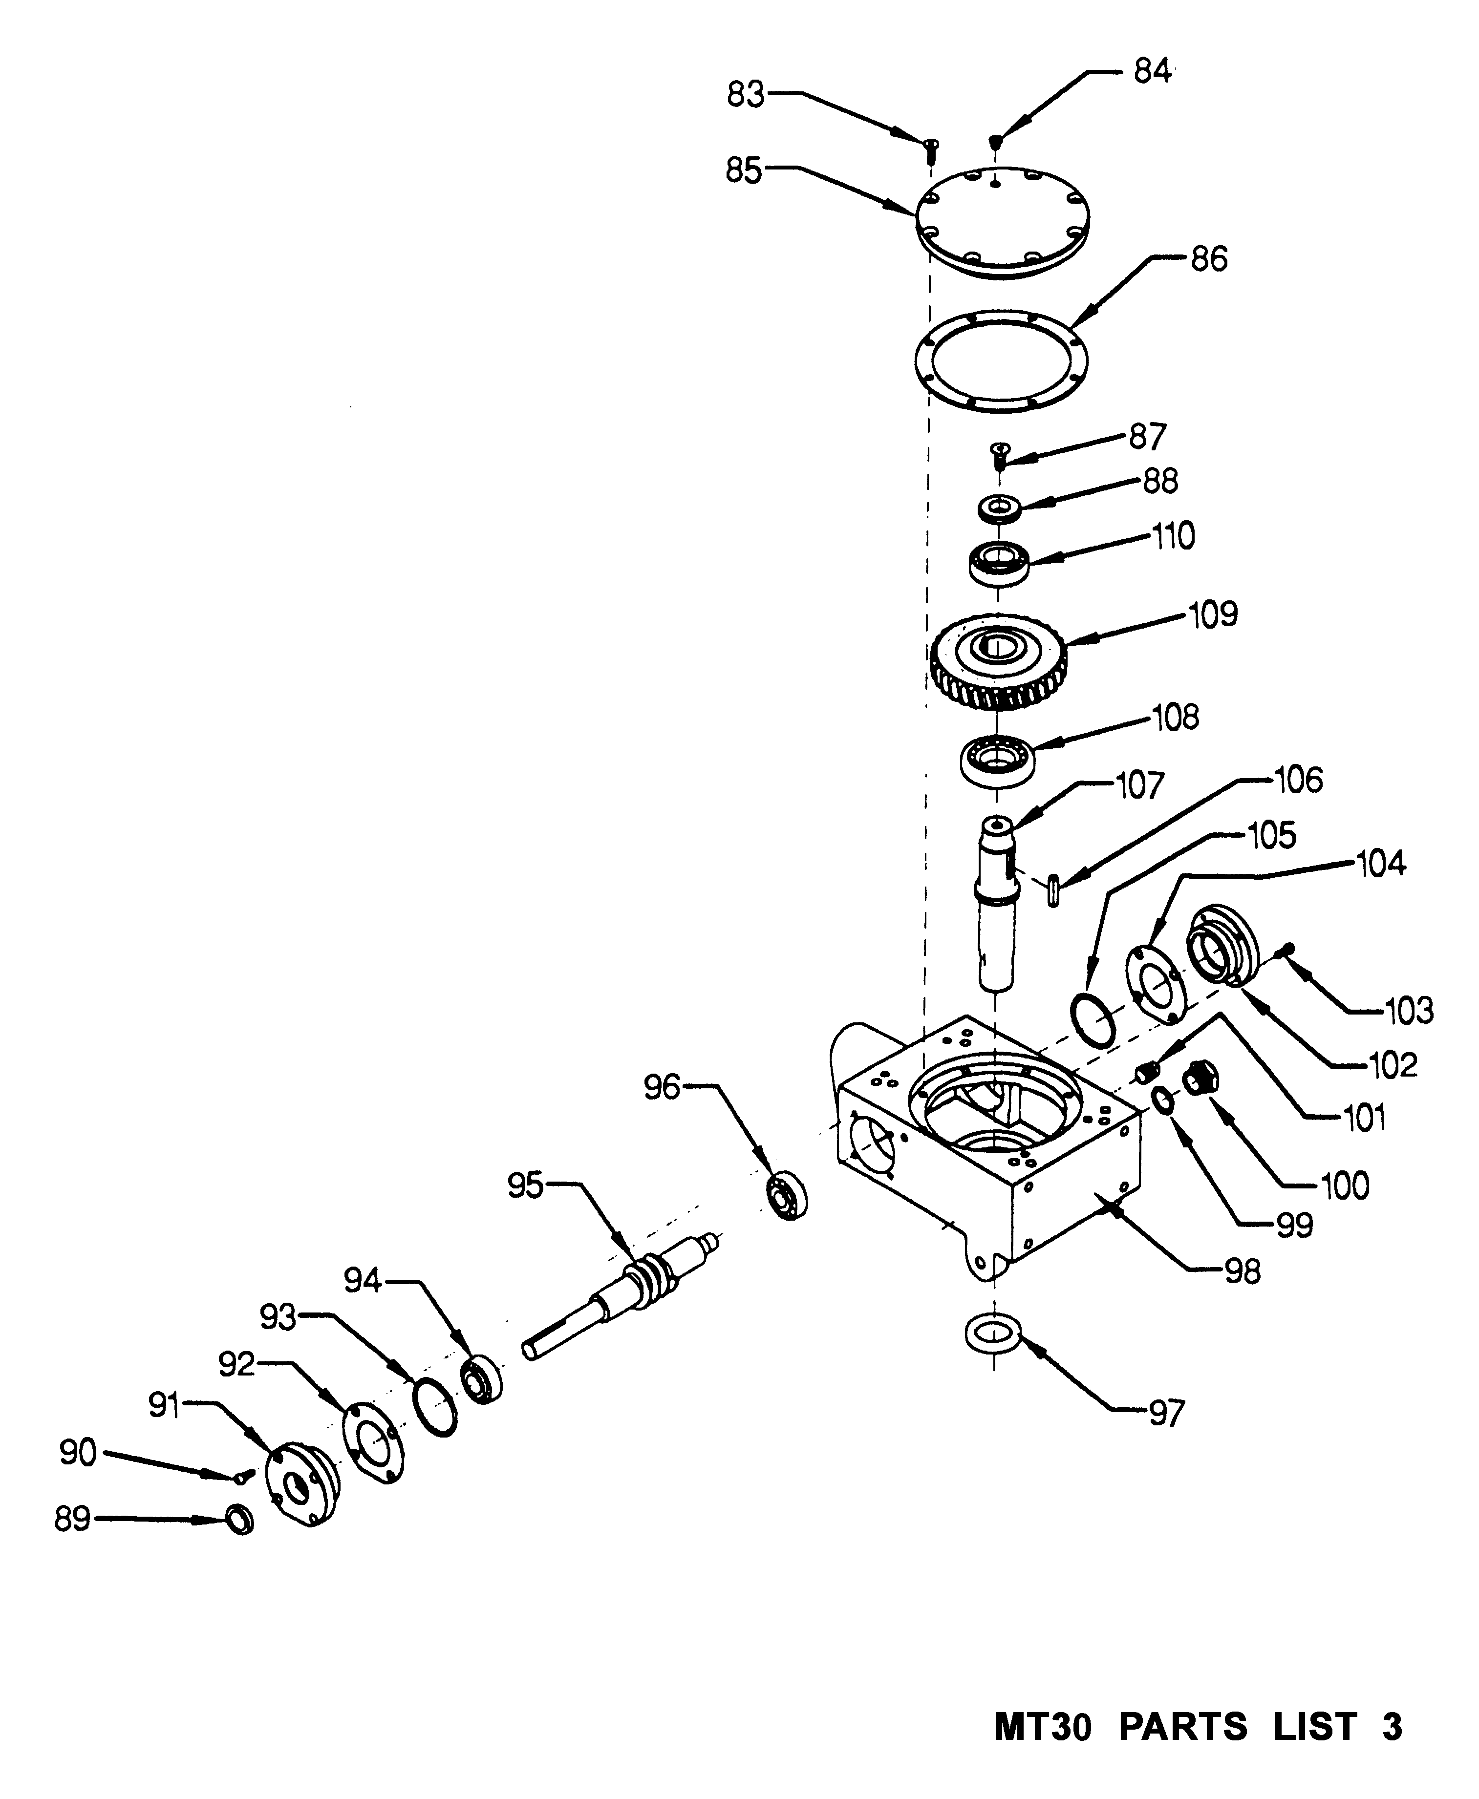
MT24 / MT30 PARTS LIST 3
MT24 / MT30 PARTS LIST 3

ITEM NO. | PART NO. | DESCRIPTION | QTY
83 | M300600001 | SCREW M8 | 8
84 | M300600002 | SCREW | 1
85 | M300600003 | COVER, GEAR BOX | 1
86 | M300600004 | SEAL | 1
87 | M300600005 | SCREW M10 | 1
88 | M300600006 | SPACER | 1
89 | M300600007 | SEAL | 1
90 | M300600008 | SCREW | 4
91 | M300600009 | FLANGE, INPUT SHAFT | 1
92 | M300600010 | PLATE, SEAL | 1
93 | M300600011 | O-RING | 1
94 | M300600012 | BEARING | 1
95 | M300600013 | GEAR, WORM & SHAFT ASSY. | 1
96 | M300600014 | BEARING | 1
97 | M300600015 | SEAL, OIL | 1
98 | M300600016 | CASE, GEAR | 1
99 | M300600017 | SEAL | 1
100 | M300600018 | SIGHT GLASS | 1
101 | M300600019 | FITTING, PLUG | 2
102 | M300600020 | FLANGE | 1
103 | M300600021 | SCREW M6 | 4
104 | M300600022 | SEAL | 1
105 | M300600023 | O-RING | 1
106 | M300600024 | KEY | 1
107 | M300600025 | SHAFT | 1
108 | M300600026 | BEARING | 1
109 | M300600027 | GEAR, WORM | 1
110 | M300600028 | BEARING | 1

Distributed By

MASALTA ENGINEERING CO., LTD

Add: Weisi Road, Baohe Industrial Estate, Hefei, China Tel: 86-551-4846600, 4846601 Fax: 86-551-4846616 E-mail: sales@masalta.com.cn, masalta@mail.hf.ah.cn, Http://www.masalta.com.cn

Version: 01/08/02

